Šablona: ČG2 - II
Vzdělávací oblast: 2 Člověk ve společnosti
Vzdělávací okruh: Jazyk a jazyková komunikace
Třída: 9.
Učivo: Nezkusit ani jednu

O jakou drogu se jedná? Zakroužkuj jednu správnou odpověď.

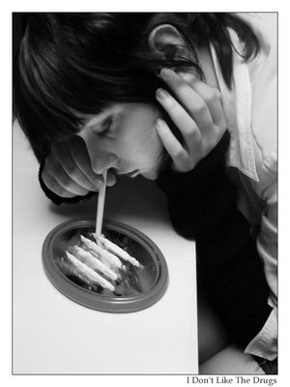1.
a) alkohol

b) marihuana

c) pervitin

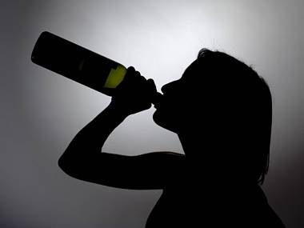2.
a) kokain

b) toluen

c) alkohol

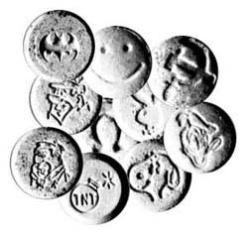 3.
a) extáze

b) kokain

c) toluen
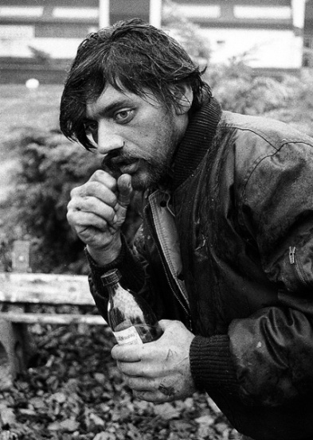 4.
a) heroin

b) toluen

c) pervitin
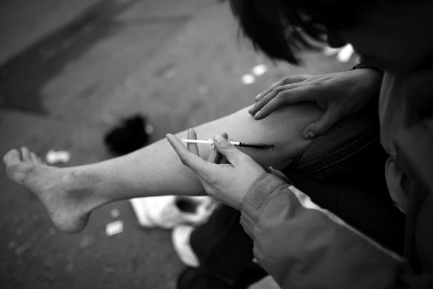 5.
a) alkohol
b) extáze
c) heroin
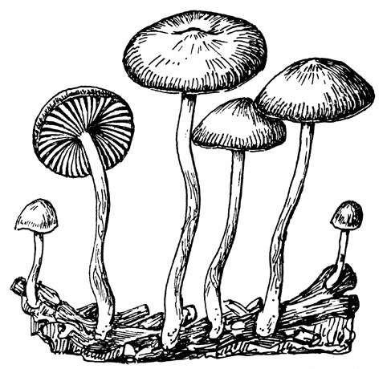 6.
a) pervitin

b) lysohlávky

c) heroin
7.
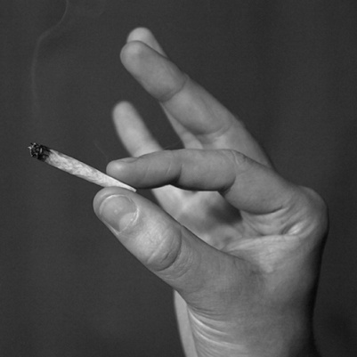8.
a) lysohlávky

b) marihuana

c) extáze

Odkazy obrázků:

- http://www.google.cz/imgres?q=marihuana&start=123&hl=cs&safe=off&as_st=y&biw=1163&bih=577&addh=36&tbs=ic:gray&tbm=isch&tbnid=LP35tthFwxfPGM:&imgrefurl=http://dcist.com/2011/05/theyre_both_individuals_and_organiz.php&docid=ZIxBWKXS_0R-QM&imgurl=http://dcist.com/attachments/Aaron%252520Morrissey/2011_0518_joint.jpg&w=500&h=500&ei=Pvl6T83nO-Tj4QTP8umHBA&zoom=1&iact=hc&vpx=215&vpy=49&dur=462&hovh=225&hovw=225&tx=133&ty=123&sig=109122813168542054378&page=6&tbnh=127&tbnw=110&ndsp=27&ved=1t:429,r:14,s:123
- http://www.google.cz/imgres?q=pervitin&num=10&hl=cs&safe=off&as_st=y&biw=1163&bih=577&tbs=ic:gray&tbm=isch&tbnid=4QFXGRLexUVggM:&imgrefurl=http://speelaczbcrew.txt.cz/clanky/34489/pervitin/&docid=Xn2MaQsCxYgdnM&imgurl=http://speelaczbcrew.txt.cz/obrazky/lajna.jpg&w=300&h=400&ei=2PR6T4flKcOHhQem1cVF&zoom=1&iact=rc&dur=222&sig=109122813168542054378&sqi=2&page=1&tbnh=150&tbnw=113&start=0&ndsp=11&ved=1t:429,r:0,s:0&tx=75&ty=86
- http://www.google.cz/imgres?q=alkohol&start=176&num=10&hl=cs&safe=off&as_st=y&biw=1163&bih=577&tbs=ic:gray&tbm=isch&tbnid=8sxuOvDV4zaOFM:&imgrefurl=http://www.denik.cz/poradna/lsd_davka_alkoholismus_vyzkum.html&docid=RHEzpgYUcmUCpM&imgurl=http://g.denik.cz/1/05/alkohol-lsd_denik-380.jpg&w=380&h=285&ei=_fh6T43kLof04QTV3OSHBA&zoom=1&iact=rc&dur=600&sig=109122813168542054378&page=8&tbnh=123&tbnw=164&ndsp=25&ved=1t:429,r:22,s:176&tx=71&ty=42
- http://www.google.cz/imgres?q=toluen&hl=cs&safe=off&sa=X&as_st=y&biw=1163&bih=577&tbs=ic:gray&tbm=isch&tbnid=59i_SV_3FbkT3M:&imgrefurl=http://slayeress.blog.cz/0810/toluen&docid=xMfiwPtIWCiEZM&imgurl=http://nd01.jxs.cz/744/587/f4ce6f6c52_35020869_o2.jpg&w=426&h=600&ei=4PV6T_ulLIbV4QSo34WIBA&zoom=1&iact=hc&vpx=105&vpy=161&dur=135&hovh=267&hovw=189&tx=124&ty=95&sig=109122813168542054378&page=1&tbnh=168&tbnw=119&start=0&ndsp=11&ved=1t:429,r:0,s:0
- http://www.google.cz/imgres?q=kokain&start=86&num=10&hl=cs&safe=off&as_st=y&biw=1163&bih=577&addh=36&tbs=ic:gray&tbm=isch&tbnid=J_thBw-CVs0esM:&imgrefurl=http://nname.org/2008/03/19/%25D0%25B4%25D0%25B0-%25D1%2582%25D0%25B8-%25D1%2581%25D0%25B5-%25D0%25BD%25D0%25B0%25D0%25BC%25D0%25B8%25D1%2580%25D0%25B0-%25D0%25BD%25D0%25B5%25D1%2589%25D0%25BE-%25D0%25B1%25D0%25B5%25D0%25BB%25D0%25BE/&docid=SBOjgTCuURSLKM&imgurl=http://nname.org/wp-content/uploads/2008/03/kokain.jpg&w=380&h=245&ei=nvh6T8O1K4Hm4QTx_7mHBA&zoom=1&iact=rc&dur=301&sig=109122813168542054378&page=5&tbnh=123&tbnw=170&ndsp=26&ved=1t:429,r:2,s:86&tx=83&ty=57
- http://www.google.cz/imgres?q=heroin&hl=cs&safe=off&as_st=y&biw=1163&bih=577&tbs=ic:gray&tbm=isch&tbnid=PPmyjKbgdGBd9M:&imgrefurl=http://npac.ca/%3Fp%3D1485&docid=HGRLg8Fwfj_pqM&imgurl=http://npac.ca/wp-content/uploads/2009/01/hayter_heroin1.jpg&w=600&h=400&ei=6_Z6T6HxG9DZ4QSR8uyHBA&zoom=1&iact=hc&vpx=850&vpy=66&dur=2800&hovh=183&hovw=275&tx=145&ty=103&sig=109122813168542054378&page=2&tbnh=125&tbnw=167&start=10&ndsp=28&ved=1t:429,r:27,s:10
- http://www.google.cz/imgres?q=lysohl%C3%A1vky&num=10&hl=cs&safe=off&as_st=y&biw=1163&bih=577&tbs=ic:gray&tbm=isch&tbnid=nNCdHT1DjWyw4M:&imgrefurl=http://mr.fr.sweb.cz/h6.html&docid=x3jPwD4_loShAM&imgurl=http://mr.fr.sweb.cz/lycesk.jpg&w=487&h=460&ei=4fl6T7r7Kcy6hAf9iMBO&zoom=1&iact=hc&vpx=327&vpy=94&dur=8195&hovh=218&hovw=231&tx=96&ty=98&sig=109122813168542054378&sqi=2&page=1&tbnh=164&tbnw=169&start=0&ndsp=10&ved=1t:429,r:1,s:0
- http://www.google.cz/imgres?q=ext%C3%A1ze&num=10&hl=cs&safe=off&as_st=y&biw=1163&bih=577&tbs=ic:gray&tbm=isch&tbnid=qZU1AESVr1R2VM:&imgrefurl=http://blog.retrodesign.us/read/172&docid=2mR4We3v-CK28M&imgurl=http://blog.retrodesign.us/upload/image/articles/extaze-1_big.jpg&w=250&h=238&ei=bfp6T4PFJIfDhAeJorFI&zoom=1&iact=hc&vpx=115&vpy=224&dur=4862&hovh=190&hovw=200&tx=83&ty=87&sig=109122813168542054378&sqi=2&page=1&tbnh=146&tbnw=149&start=0&ndsp=12&ved=1t:429,r:0,s:0

